
Buckingham Swans Swimming Club
Swan Pool, Buckingham, MK18 1AE

Buckingham’s own swimming club

- flexible, low cost training for competent swimmers
aged 9 years and over
- experienced and highly qualified coaches
- friendly and thriving club
- ideal next step after the ‘Swim Life’ programme

At BSSC, we offer training for a wide range of swimming abilities, from once or twice a week for fitness/recreational swimmers, to 5 times a week for higher level competitive swimmers – try us out!

Swimmer and stroke development is important, and our coaches will teach you to swim the 4 strokes effectively, and to compete – we have county and regional standard swimmers in our membership.
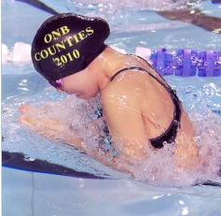
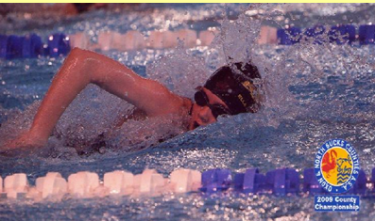

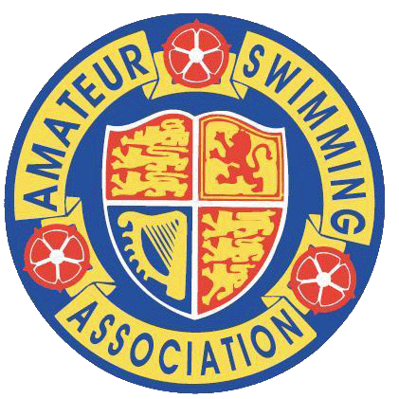

For more information, visit www.buckinghamswanssc.co.uk

